Registering

To register an account, the user must go to the login page and enter a username into the ‘register’ field before pressing ‘return.’ The page will then tell them their user ID.

Logging in

To log in, the user must go to the login page and enter their account ID into the ‘login’ field before pressing ‘return.’ They will then be redirected to the homepage.

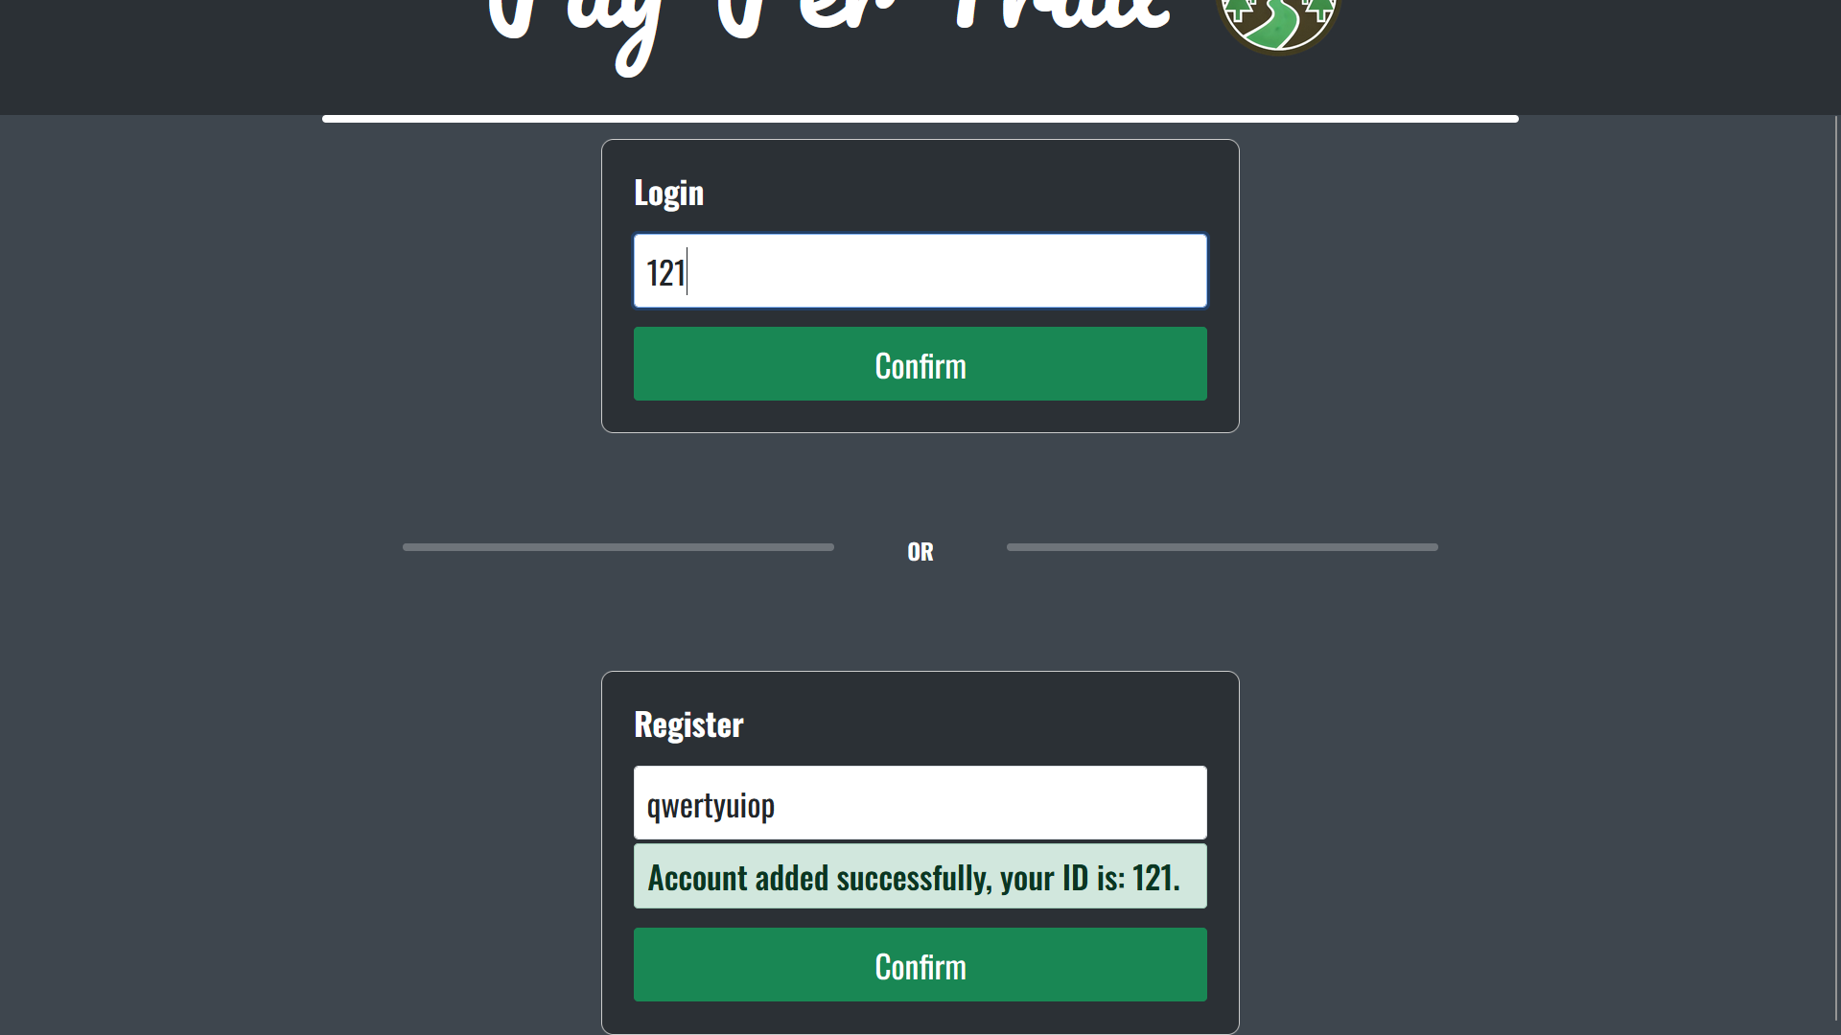

Making a transaction

To make a transaction, the user must first go to the Add Payee page (reachable from the homepage or the task bar) and enter the ID of whoever they want to make a transaction with. After registering a payee they must then go to the Pay page, find the user they wish to make a transaction with in the alphabetically-sorted list, and click the Pay button next to their name. This will then bring them to the payment page, where they can enter the amount of money they wish to pay (which cannot be lower than zero) and write a reference. They can finalise the transaction by pressing Continue and then Confirm, or can press Edit after pressing Continue if they wish to edit their transaction.

Deleting a payee

The user can delete a payee by going to the Pay page and pressing the Delete button next to a given user’s name.

Levelling up

The user can level up by increasing their XP. XP is increased by making transactions, and more XP will be earned from transaction made with companies with higher environmental impact ratings. The user can view their XP and level by going to the Green Score page.

Earning rewards

Rewards can be earned by levelling up. Each reward has a set level at which the user will earn the reward. Rewards can be viewed on the Green Score page.

Viewing past transactions

The user can see a list of all their past transactions, sorted by most recent, on the homepage. They can view the details of each transaction by clicking on it.

Finding alternative companies

The details page of a given transaction will also display the highest-rated companies which are in the same spending category as the company with which the transaction was made. This list can be browsed by clicking the arrows on either side of the displayed company. This can be used to find greener alternatives to a given company. There is also a list of the overall highest-rated companies on the Green Score page.

Logging out

The user can log out by going to the Settings page, which is the last item on the nav bar, and then selecting “log out”.